THEORY (Question 3 is compulsory for ss3)

1. (a) What is meant by resonance (b) Describe an experiment to determine the velocity of sound in air (c) As a ship approaches a cliff, its siren is sounded and the echo is heard in the ship after 12 seconds. 2.1 minutes later the siren is sounded again and the echo is heard 8 seconds later. If the speed of the sound in air is 340m/s, calculate the velocity at which the ship is approaching the cliff.
2. A wire is gradually stretched by loading it until it snaps. (a) sketch a load-extension graph for the wire (b) indicating on the graph (i) elastic limit (ii) yield point (iii) breaking point (c) A force of 40 N is applied at the end of a wire fixed at one end to produce an extension of 0.24mm. if the original length and diameter of the wire are 3m and 2mm respectively. Calculate (i)stress on the wire (ii)strain in the wire
3. (a) Explain the terms ***critical angle*** and ***total internal reflection*** (b) the angle of refraction (r) of a ray of white light from air through a triangular glass prism of refractive index 1.5 is 29°. Calculate the angle through which the ray is least deviated. (c) Study the diagram below and use it to answer the question that follow

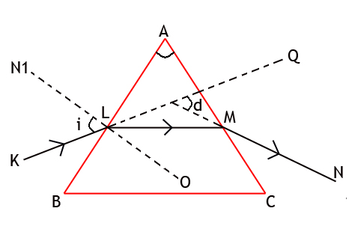

Calculate (i)value of **P**, **Q** and **R** (ii) refractive index n of the glass prism (iii) value of **e** (iv) total deviation **D**

1. (a) Draw and label a diagram of a pulley system with a velocity ratio of 5 (b) Show that the efficiency of a machine ξ, the force ratio M.A and the velocity ratio V.R are related by the equation ξ = $\frac{M.A }{V.R}$ x 100% (c) The efficiency ξ of a machine is 80%. Calculate the work done by a person using the machine to raise a load of 300kg through a height of 4m (g = 10m/s2).
2. (a) Draw a clearly labelled diagram to illustrate how two converging lenses maybe arranged to form a compound microscope (b) An object 2.5mm long is viewed through a converging lens of focal length 10cm held close to the eye. A magnified image of the object is formed 30cm from the lens. Calculate the (i) distance of the object from the lens (ii) size of the image (iii) power of the lens
3. (a) Explain why white light is dispersed when it passes through a glass prism(b) State the colours in the spectrum of white light in ascending order of wavelength (ii) which colour is deviated *least* and *most* (c) Describe with the aid of a labelled diagram, how a pure spectrum of white light can be produced on a screen.
4. Explain the following term (i) Viscosity (ii) terminal velocity (b) State two (i) effects of viscosity (ii) application of viscosity (c)A ball bearing falls through a viscous liquid. Using a labelled diagram of a tall vessel, show the forces acting on it (ii) When will it attain terminal velocity?
5. Explain the rise of water in a glass capillary tube using kinetic theory (b) Define angle of contact, draw sketches to show angles of contact for a capillary tube dipped vertically in (i) water (ii) mercury. (c) State three differences between crystalline and amorphous substances. (ii) Give two examples of each
6. An electric bell takes a current of 0.2A from a battery of two dry cells connected in series. Each cell has an emf of 1.5V and an internal resistance of 1.0Ω (i)calculate the effective resistance of the bell (ii) what current would the bell take if the cells were arranged in parallel. (c) A battery of e.m.f 12V and internal resistance 0.5Ω is connected to 1.5Ω and 4.0Ω series resistor. Calculate the terminal voltage.
7. A landlord has eight 40W electric light bulbs, four 60W bulb and 100W bulb in his house. If he has all the points on for five hours daily and if NEPA charges 80k per unit, calculate his bill for 30 days. (b) Electrical energy can be converted into other forms of energy, mention any three and give two examples of an equipment/device undergoing such change (c) Prove that W = V2t/R
8. Briefly explain the working principle of either a fuse or a circuit breaker (b) What is a continuity test (ii) Sketch a simple diagram of a continuity tester (c) Using the following devices- voltmeter, ammeter, cell, key, a resistor , connecting wire, using the electrical symbol of each device given above draw a circuit diagram to show (i) an open circuit(ii) a close circuit